RVA can be constructed in two ways

Assume the representation for a word *w* is a summation of the contexts in which the words occurred:

$$w=c_{1}+c_{2}$$

The construction of the context of a word could be the summation of the environment vectors representing the words that occurred in the context. For instance,

$$c_{1}=e_{1}+e_{2}$$

$$c_{2}=e_{1}+e_{3}$$

Then the representation of the word is:

$$w=c_{1}+c_{2}$$

$$w=e_{1}+e_{2}+e_{1}+e_{3}$$

$$w={2e}_{1}+e_{2}+e_{3}$$

Alternatively, rather than construing the context as a summation, the vectors composing the context vector could be convolved into a vector that uniquely represents the context

$$c_{1}=e_{1}⨂e_{2}$$

$$c_{2}=e_{1}⨂e_{3}$$

By properties of convolution, c1 and c2 are orthogonal vectors (given that the environmental vectors are orthogonal). Therefore, convolutional bindings yield a different model from the summation of environmental vectors.

I used measures of first and second order statistics to yield these baseline heatmaps for word similarities:

Expected first order based on jaccard index

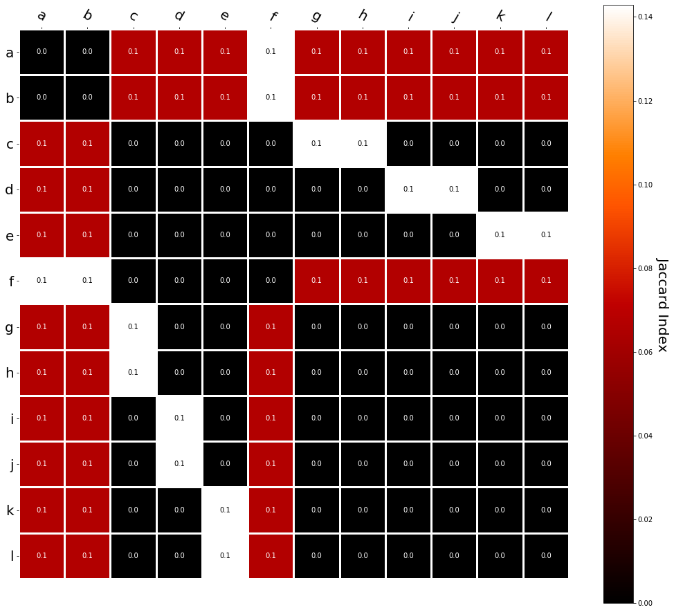

Expected second order based on jaccard index

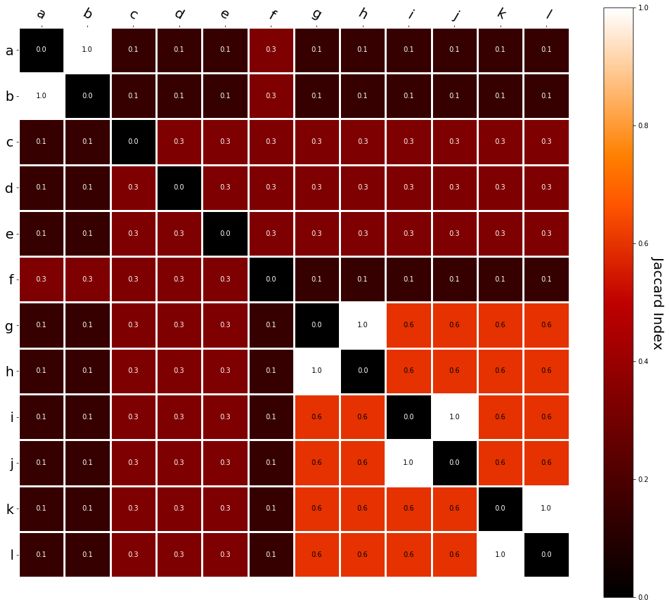

First order information using convolutional bindings:

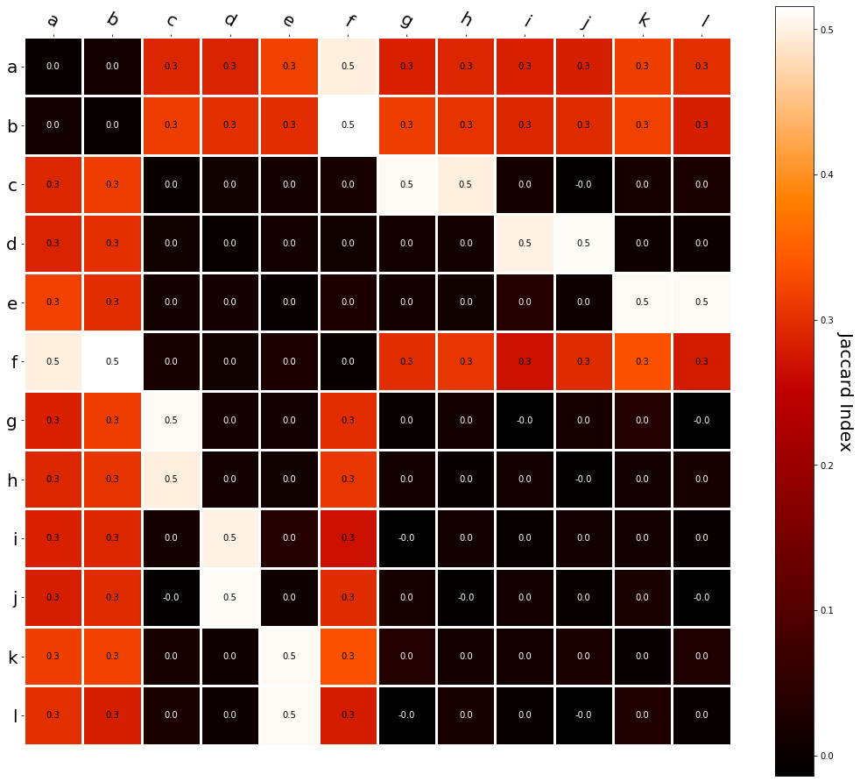

Second order information using convolutional bindings:

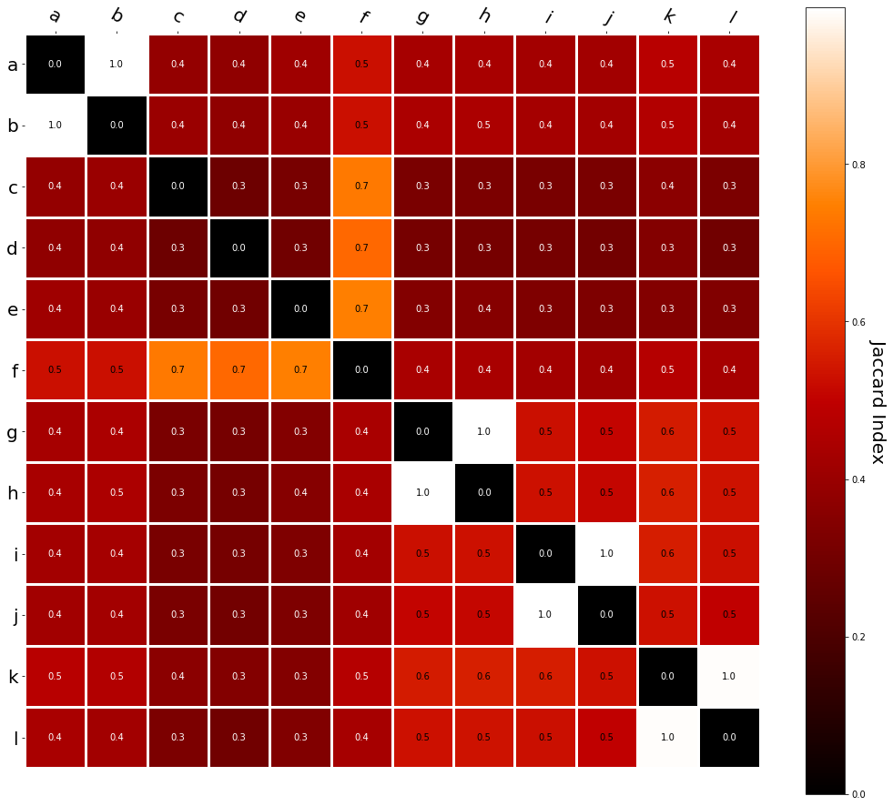

First order information using summation:

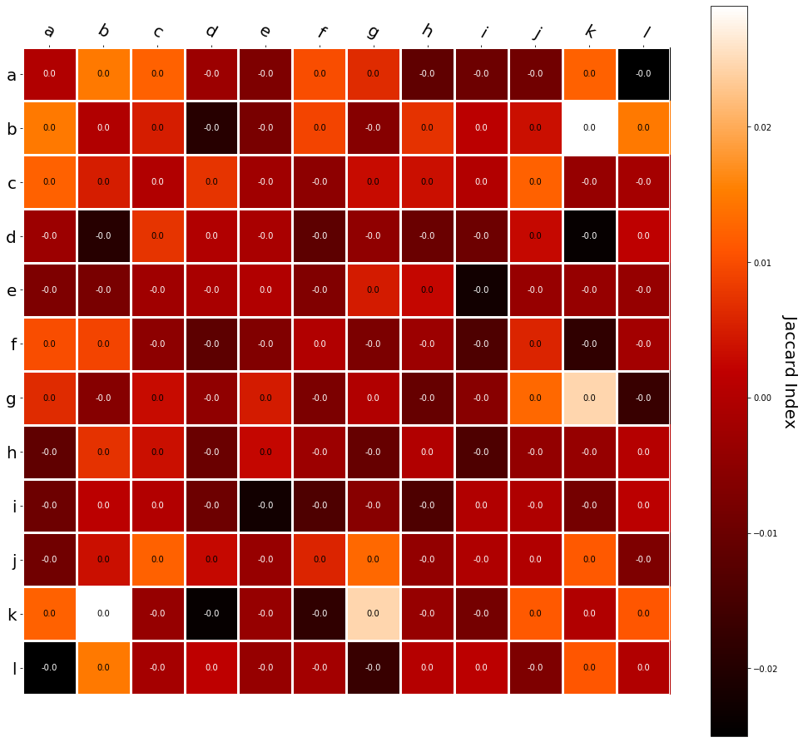

Second order information using summation:

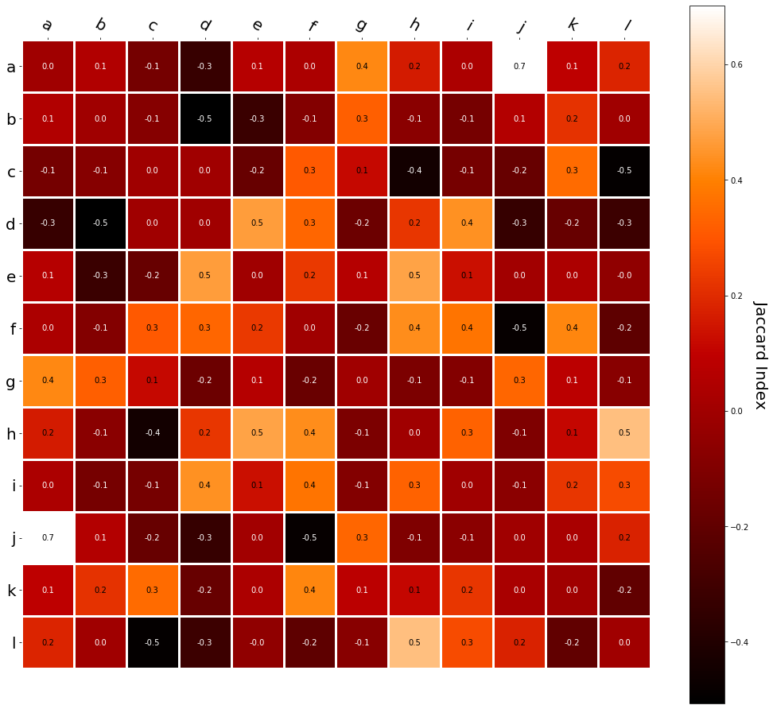

It appears that binding contexts into a unique and orthogonal vectors is necessary in order to adequately recreate first and second order information. Additionally, this highlights how effective mapping a localist representation to a random vector could be for data reduction. (Later tests could involve RVA capacity – I can’t find sources that directly address this. Maybe plate has this info). (Also, could I make an incremental learner where environmental vectors aren’t previously assigned, but weights update iteratively based on co-activation?)